|  |  |
| --- | --- |
| Description: Vertical full colour positive | Safety Bay Senior High School |

|  |  |  |  |  |  |  |
| --- | --- | --- | --- | --- | --- | --- |
|  |  | | | | | |
| **CHEMISTRY UNIT 3 & 4** | | | | | | |
| **Test #3:** | | | | | | |
| **Oxidation and Reduction** | | | | | | |
|  | | | | | | |
| **NAME:** | | |  | | | |
|  | | |  | | | |
| **Time allowed for this paper** | | | | | | |
| Reading time: | | 5 minutes | | | | |
| Working time: | | 50 minutes | | | | |
|  | | | | | | |
| **Structure of this paper:** | | | | | | |
| Section | | | Number of questions | Marks available | | Marks achieved |
| Section One: Multiple Choice | | | 8 | 8 | |  |
| Section Two: Short Answer | | | 7 | 42 | |  |
|  | | |  | | **Total** | ______ / 50 |

**Section One: Multiple Choice**

Answer all questions by circling the correct option. Only circle one option for each question.

1. The oxidation number for chromium in the dichromate ion (Cr2O72–) is:
   1. +3
   2. +4
   3. +5
   4. +6
2. The oxidation number for sodium in sodium peroxide (Na­2O2) is:
   1. +1
   2. +2
   3. +3
   4. +4

**Questions 3-4 refer to the following reaction:**

2 NaOH + Cℓ2 → NaCℓ + NaCℓO + H2O

1. Which option on the table below correctly identifies the oxidant and reductant in the above reaction?

**Oxidant Reductant**

* 1. NaOH Cℓ2
  2. Cℓ2 NaOH
  3. NaOH NaOH
  4. Cℓ2 Cℓ2

1. What term is used to describe this reaction?
   1. Displacement reaction
   2. Acid-base reaction
   3. Disproportionation reaction
   4. Electrolytic reaction
2. Which of the following chemical species is capable of converting Cu2+ into Cu(s)?
   1. Pt
   2. Fe
   3. Au
   4. HCℓ
3. Which of the following describes the halogens as you go down Group 17?
   1. They become stronger reductants
   2. They become weaker reductants
   3. They become stronger oxidants
   4. They become weaker oxidants

**Question 7 refers to the following electrochemical cell:**

KNO3 salt bridge

platinum electrode

copper electrode

Fe3+

V

Fe2+

SO42-

Cu2+

SO42-

Reduction half-equations:

Fe3+ + e⁻ → Fe2+ E° = 0.77 V

Cu2+ + 2 e⁻ → Cu E° = 0.34 V

1. Which of the following equations would be used to calculate the voltage of the cell under standard conditions?

|  |  |
| --- | --- |
| (a) |  |
| (b) |  |
| (c) |  |
| (d) |  |

1. Why does the hydrogen half-equation (2 H+ + 2 e⁻ → H2) have a standard reduction potential of 0.000 V?
   1. The value has been measured very precisely
   2. It is an arbitrary set reference
   3. Hydrogen ions have no ability to attract electrons
   4. The half-cell cannot produce current

**Section Two: Short Answer**

Write your answers in the spaces provided.

1. **(7 marks)**
   1. Write balanced ionic equations, including state symbols, for the following reactions: (3 marks)
      1. Zinc is added to a solution of nickel(II) sulfate.

* + 1. Fluorine gas is bubbled through a solution of potassium iodide.

* 1. Explain why the reaction in Q9(a)(i) is considered a ‘redox’ reaction. (2 marks)

* 1. Describe what would be observed in the beaker as the reaction in Q9(a)(i) occurs. (2 marks)

1. **(4 marks)**

The following reaction shows a process used in the extraction and purification of gold:

Au(s) + 3 HNO3(aq) + 4 HCℓ(aq) → HAuCℓ4(aq) + 3 NO2(g) + 3 H2O(ℓ)

Identify the oxidising agent and reducing agent in this reaction. Give evidence to support your answer.

1. **(7 marks)**

A galvanic cell was constructed as shown in the diagram below:

KCℓ(aq)

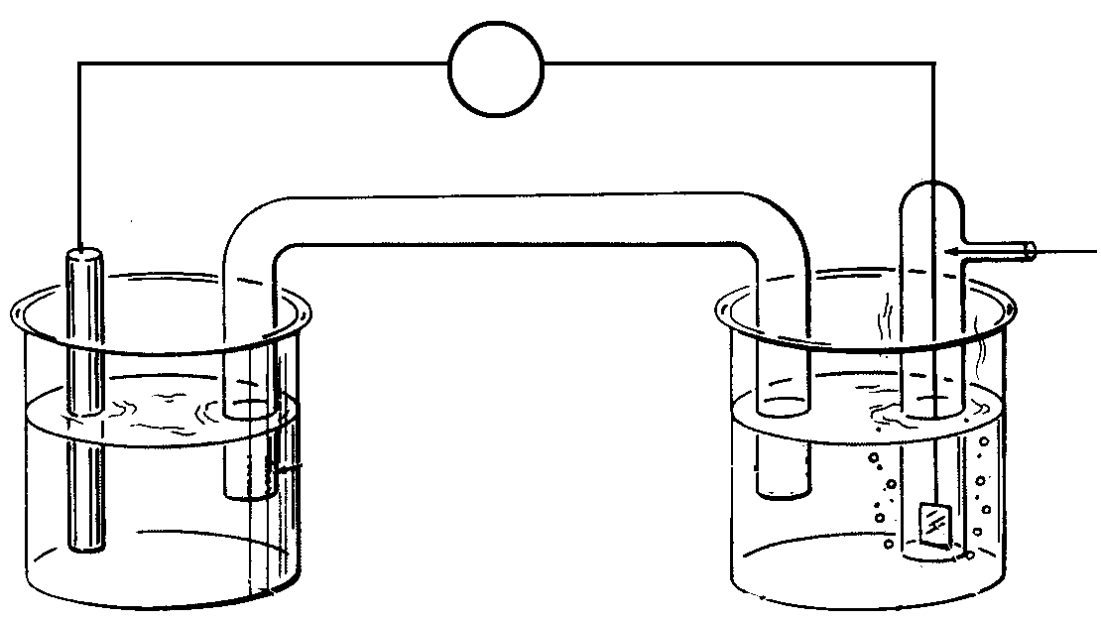

Cℓ2(g)

Pt(s)

Cr(s)

V

Salt bridge (NH4Cℓ)

CrCℓ3(aq)

A

B

* 1. Write the oxidation and reduction half-equations, and a balanced overall redox equation for this reaction. (3 marks)

|  |  |
| --- | --- |
| **Oxidation** |  |
| **Reduction** |  |
| **Overall equation** |  |

* 1. Name the anode and cathode in the above cell: (2 marks)

Anode: Cathode:

* 1. Between the points labelled A and B, show the direction of electron flow. (1 mark)
  2. Show on the diagram the direction of ion flow in the salt bridge. (1 mark)

1. **(6 marks)**

The following diagram shows a form of electrolysis:

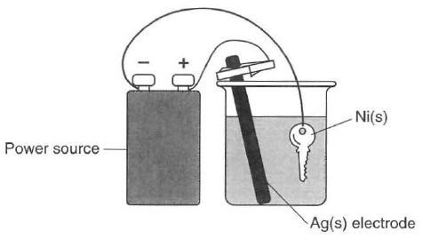

* 1. Give the name of this application of electrolysis, and describe its purpose in this particular scenario. (2 marks)

* 1. Write half-equations showing the process occurring at the: (2 marks)
     1. Anode:
     2. Cathode:
  2. Give the name or formula of a suitable electrolyte for this cell. (1 mark)

* 1. What is the purpose of the power source in this cell? (1 mark)

1. **(6 marks)**

‘Breathalysers’ are instruments used by police to measure the concentration of ethanol (C2H5OH) in a driver’s breath. One type of breathalyser used is a fuel cell. If the driver’s breath contains ethanol then a redox reaction will occur. The ethanol reacts to form ethanoic acid (CH3COOH) and oxygen from the air reacts to form water vapour. Both reactions occur in acidic conditions.

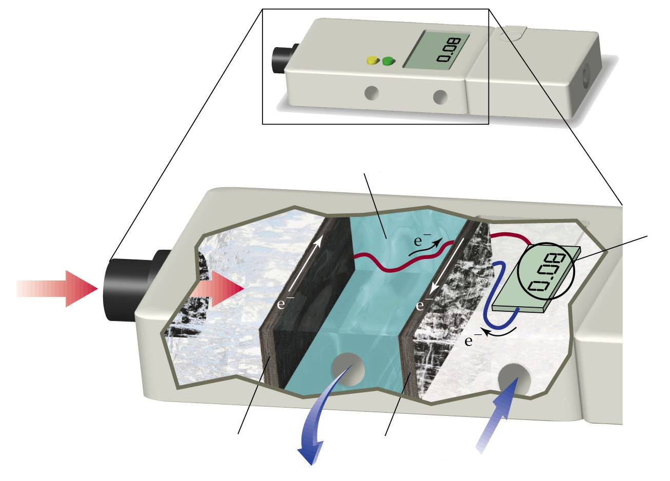

C2H5OH

acidic electrolyte

air   
intake

O2

waste   
products

Driver’s  
breath

Blood alcohol level

Electrode charge:

Electrode charge:

* 1. Complete the half-equations below to show the reactions occurring in each section of the breathalyser. Both reactions occur in acidic conditions. (4 marks)

|  |
| --- |
| C2H5OH → CH3COOH |
| O2 → H2O |

* 1. Label the diagram to show the charges of the two electrodes. (1 mark)
  2. What characteristic of this breathalyser allows it to be classified as a “fuel cell”? (1 mark)

1. **(4 marks)**

The lithium button cell, used to power watches and calculators, is a primary cell containing lithium metal. The lithium ion cell is a secondary cell that is used to power laptops.

|  |  |
| --- | --- |
| http://img.dxcdn.com/productimages/sku_34712_4.jpg | https://upload.wikimedia.org/wikipedia/commons/1/1a/Li_ion_laptop_battery.jpg |
| Lithium button cell | Lithium ion cell |

The half-equation for the reduction of lithium is:

Li+(aq) + e⁻ → Li(s) E° = -3.04 V

* 1. What is the difference between a primary and secondary cell? (1 mark)

* 1. Give one reason why lithium is used as a reactant in these galvanic cells. (1 mark)

Some early lithium metal batteries exploded when exposed to water.

* 1. Write a balanced equation for the reaction between lithium metal and water and explain why an explosion may occur. (2 marks)

1. **(8 marks)**

The bromate ion (BrO3⁻) is an ion formed by the ozonation of drinking water. Bromate ion is a powerful oxidising agent and can react in the presence of an acid to form bromine (Br2).

* 1. Write a half-equation showing the reduction of the bromate ion to form bromine. (2 marks)

* 1. Information about the oxidising power of the bromate ion can be gathered by observing what other species it is able to react with.

A student constructed the following two electrochemical cells and allowed each cell to operate for five minutes. In their notes they recorded the initial and final appearance of each half-cell. All cells were constructed under standard conditions.

**Electrochemical Cell #1 (EC1): Electrochemical Cell #2 (EC2):**

salt bridge

C(s)

BrO3⁻(aq)

Cr3+(aq)

C(s)

salt bridge

C(s)

BrO3⁻(aq)

Mn2+(aq)

C(s)

*Initial appearance:*

Pale pink solution

*Final appearance:*

Pale pink solution

*Initial appearance:*

Colourless solution

*Final appearance:*

Colourless solution

*Initial appearance:*

Green solution

*Final appearance:*

Orange solution

*Initial appearance:*

Colourless solution

*Final appearance:*

Brown solution

* + 1. Account for the colour changes in EC1 (Electrochemical Cell #1). (3 marks)

* + 1. Explain how the observations in EC1 and EC2 can be used to gain information about the standard reduction potential (E°) of bromate ions. (3 marks)